1. **Create RPA_MemoriaHealth Database in Sql Server Management Studio**

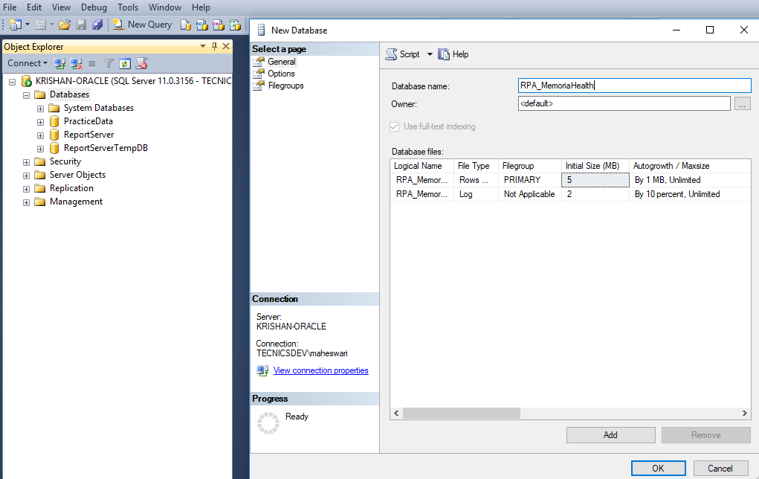

1. **Double click script.sql to open the Sql script.**

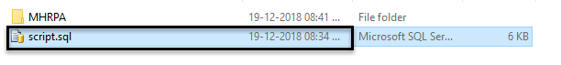

1. **Execute the Sql script to get all the tables.**

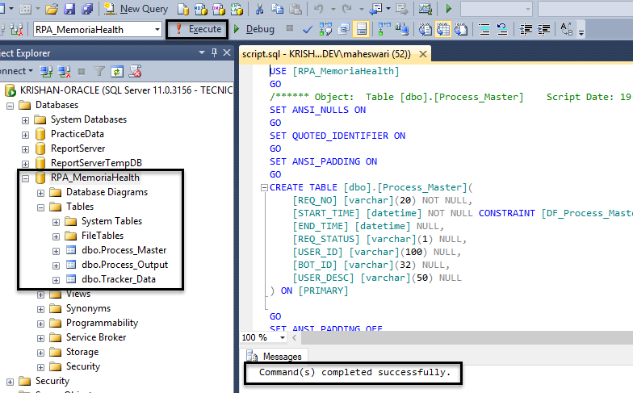

1. **Changes in Config File:**

Provide the File Paths and client file details in the *Config.xlsx* as per your workspace location.

The *Config.xlsx* file can be found here: **“MHRPA\Config\Config.xlsx”**

1. **Run Uipath Robot.**

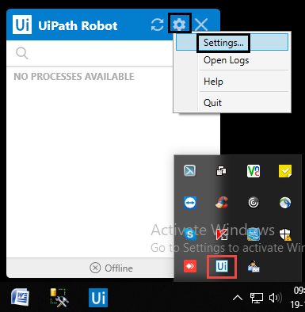

• Copy the Machine Name

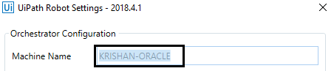

1. **Login to Orchestrator:**

<https://platform.uipath.com/account/login>

• Create the Bot by clicking on Robot tab and then by providing appropriate details.

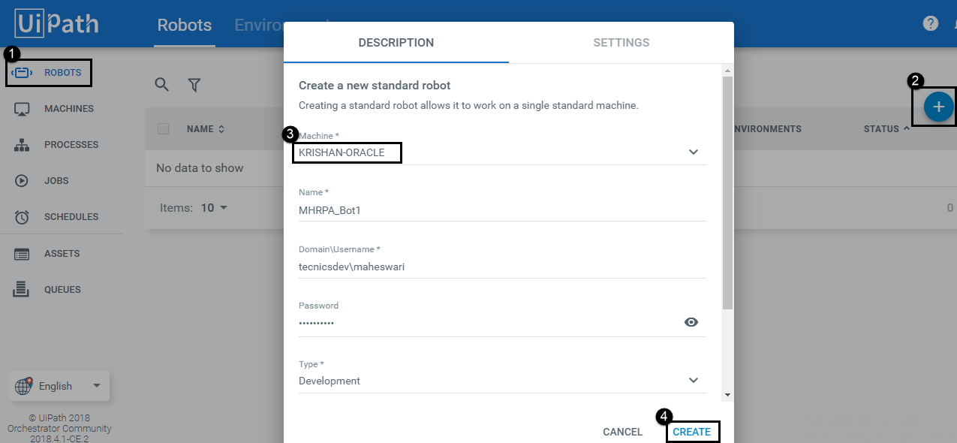

* **Register your robot with UI Orchestrator**

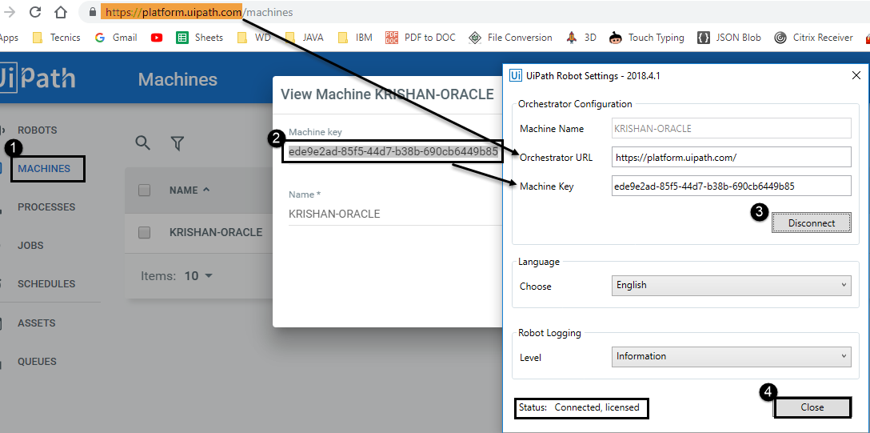

* **Publish a project in UiPath Studio to turn it into an Orchestrator Project**

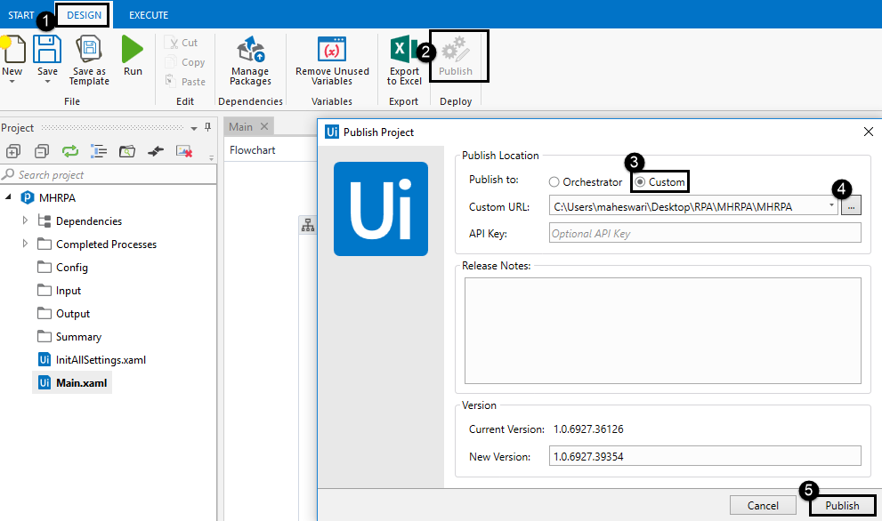

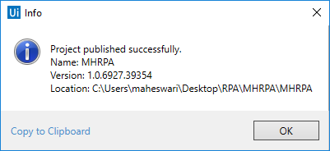

* **Create an Environment containing the Robots to use.**

• In the Manage Environment window check the bot name and Update the Environment.

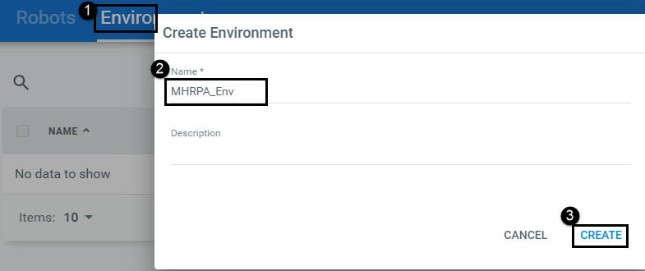

* **Go to Packages Tab and upload the build.**

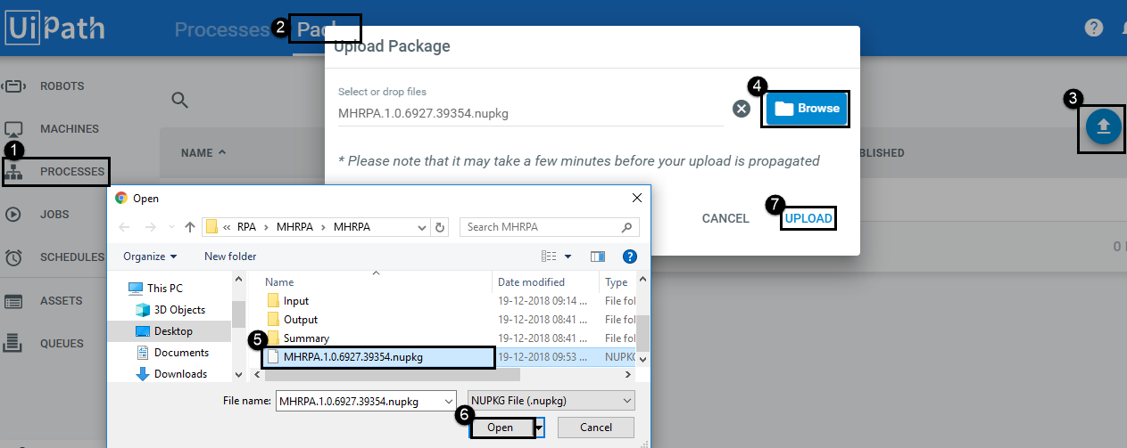

* **Create a process to link the package with previously created environment.**

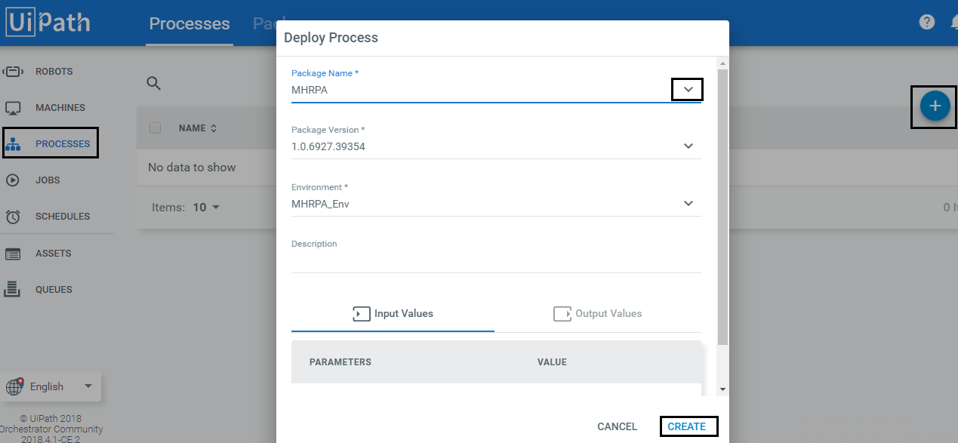

* **Create all the required assets by clicking on Assets Tab**

EX: ReqNo

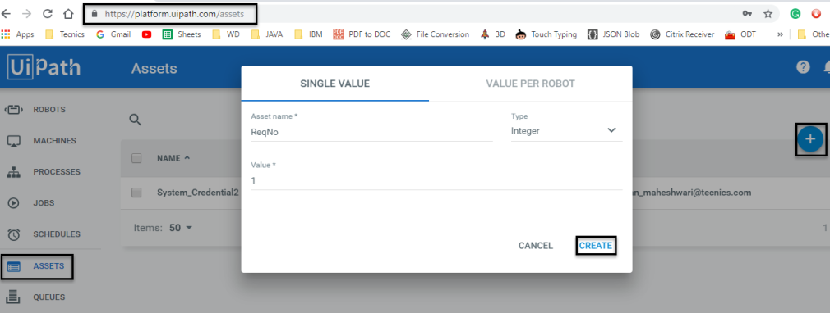

• Following Assets need to be created in Orchestrator

|  |  |
| --- | --- |
| ASSET NAME | TYPE |
| Config file path | Text |
| Input folder path | Text |
| MH file sheet name | Text |
| MH summary sheet name | Text |
| Summary file sheet name | Text |
| ReqNo | Integer |
| Datasource | Text |
| DBName | Text |
| Process master table name | Text |
| Process output table name | Text |
| Table name | Text |
| From mail id | Credential |
| Display name | Text |
| Mail body | Text |
| Subject | Text |
| Port | Text |
| Server | Text |
| To mail id | Text |

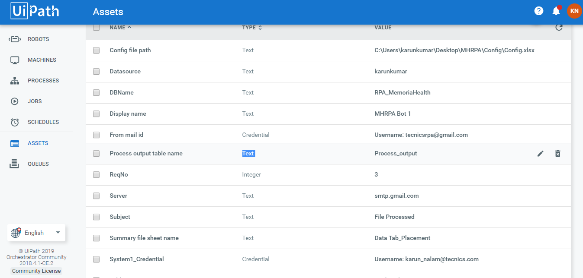

* **Start the job to execute the project.**

